2. Project Plan

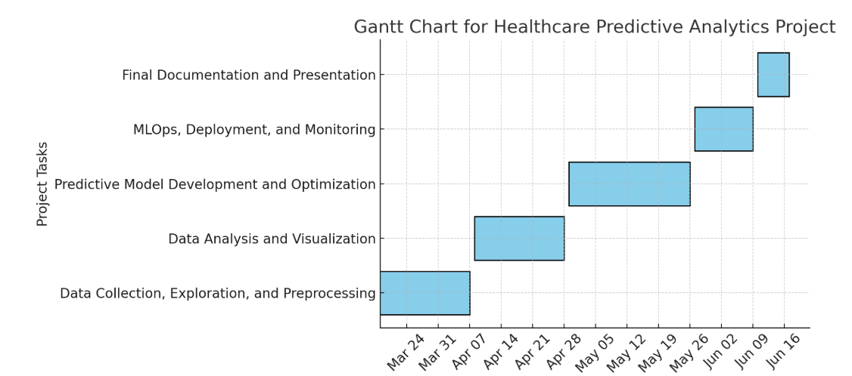

Project Timeline and Milestones

The project is divided into five key milestones, each focusing on a specific phase of development:

1. Data Collection, Exploration, and Preprocessing (Weeks 1-3)

a. Gather healthcare datasets containing patient information, medical history, and health metrics.

b. Conduct exploratory data analysis (EDA) to understand dataset characteristics, feature distributions, and potential trends.

c. Handle missing values, normalize/standardize data, and encode categorical variables for model compatibility.

d. Deliverables: Dataset Exploration Report, EDA Notebook, and a cleaned dataset ready for modeling.

2. Data Analysis and Visualization (Weeks 4-6)

a. Perform statistical analysis to understand relationships between health metrics and patient outcomes.

b. Identify key predictive features using correlation analysis and feature importance techniques.

c. Develop visualizations such as heatmaps, trend lines, and interactive dashboards for stakeholders.

d. Deliverables: Analysis Report and interactive health metrics dashboard.

3. Predictive Model Development and Optimization (Weeks 7-10)

a. Select appropriate machine learning models, including Logistic Regression, Random Forest, Gradient Boosting, or Neural Networks.

b. Train and validate models using training/testing datasets, applying cross validation to avoid overfitting.

c. Optimize model performance through hyperparameter tuning using Grid Search or Random Search.

d. Deliverables: Model code, performance report, and the final optimized predictive model.

4. MLOps, Deployment, and Monitoring (Weeks 11-12)

a. Implement MLOps practices using MLflow or Kubeflow for tracking model experiments and managing lifecycle processes.

b. Deploy the predictive model as a REST API or web application using Flask or FastAPI.

c. Set up real-time monitoring to track performance, detect model drift, and issue automated alerts for retraining if necessary.

d. Deliverables: Deployed predictive model, MLOps documentation, and monitoring setup.

5. Final Documentation and Presentation (Week 13)

a. Compile a comprehensive project report detailing data collection, preprocessing, model development, and deployment.

b. Prepare a professional presentation highlighting model functionality, business impact, and recommendations for future improvements.

c. Deliverables: Final report and presentation slides.